equals() & hashCode() (Java Core + Real Use Cases)

In Java, every object has:
- Identity → memory location
- State → data inside the object
Two objects can:
- Be different in memory
- But represent the same logical data
equals() vs ==
== | Reference equality (same memory location)
equals() | Logical/content equality (same data)

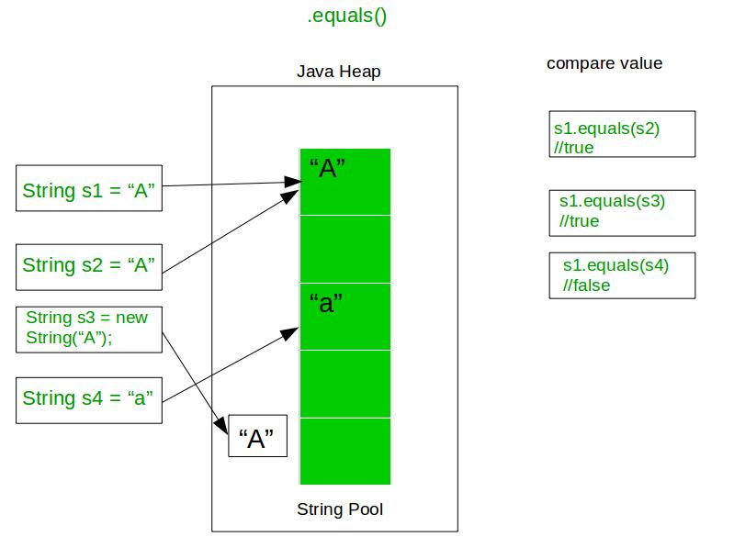
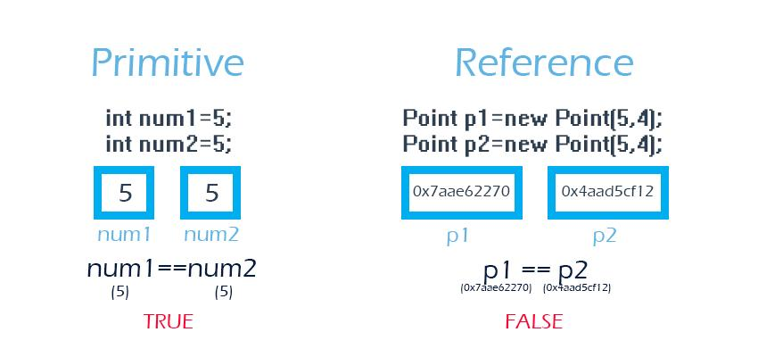
- == → compares memory
- equals() → compares content

Understanding equals()
Default Behavior (Problem)
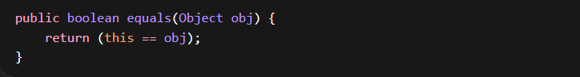This compares reference (memory address)
Why Override equals()?
Because in real applications:
- We compare objects based on business data
- Not memory
Examples:
- Two users with same email → same user
- Two employees with same ID → same entity

Example 1: Basic Object Comparison
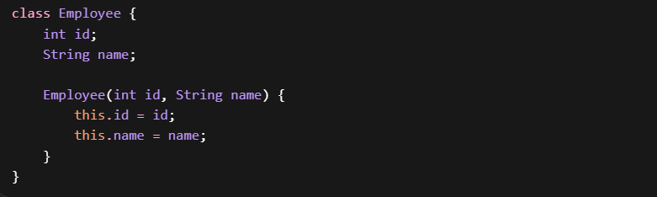
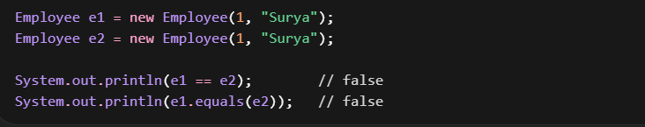
- e1 == e2 → ❌ false Different memory locations
- e1.equals(e2) → ❌ false Because default equals uses == internally

Example 2: After Overriding equals()
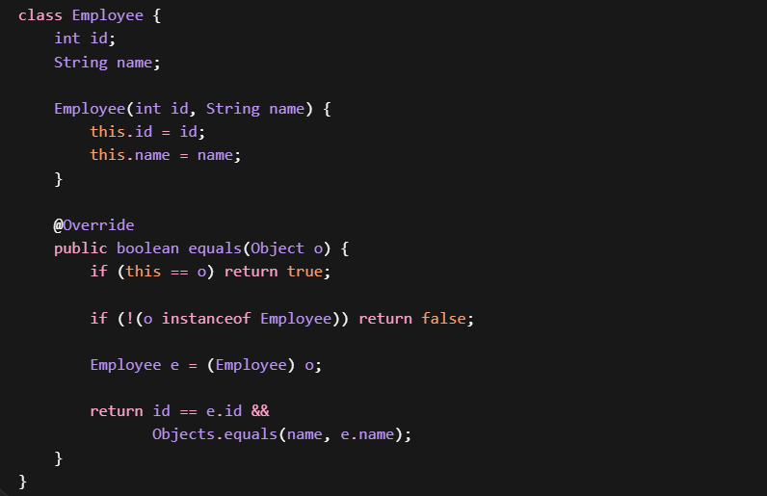

- == → still compares memory → ❌ false
- equals() → now compares fields → ✅ true

Example 3: String Special Case
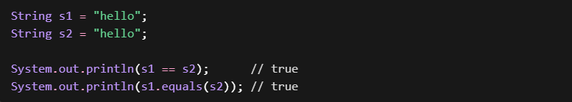Why == is TRUE here?
Because of String Pool
- Both refer to same memory location
- Java optimizes string literals
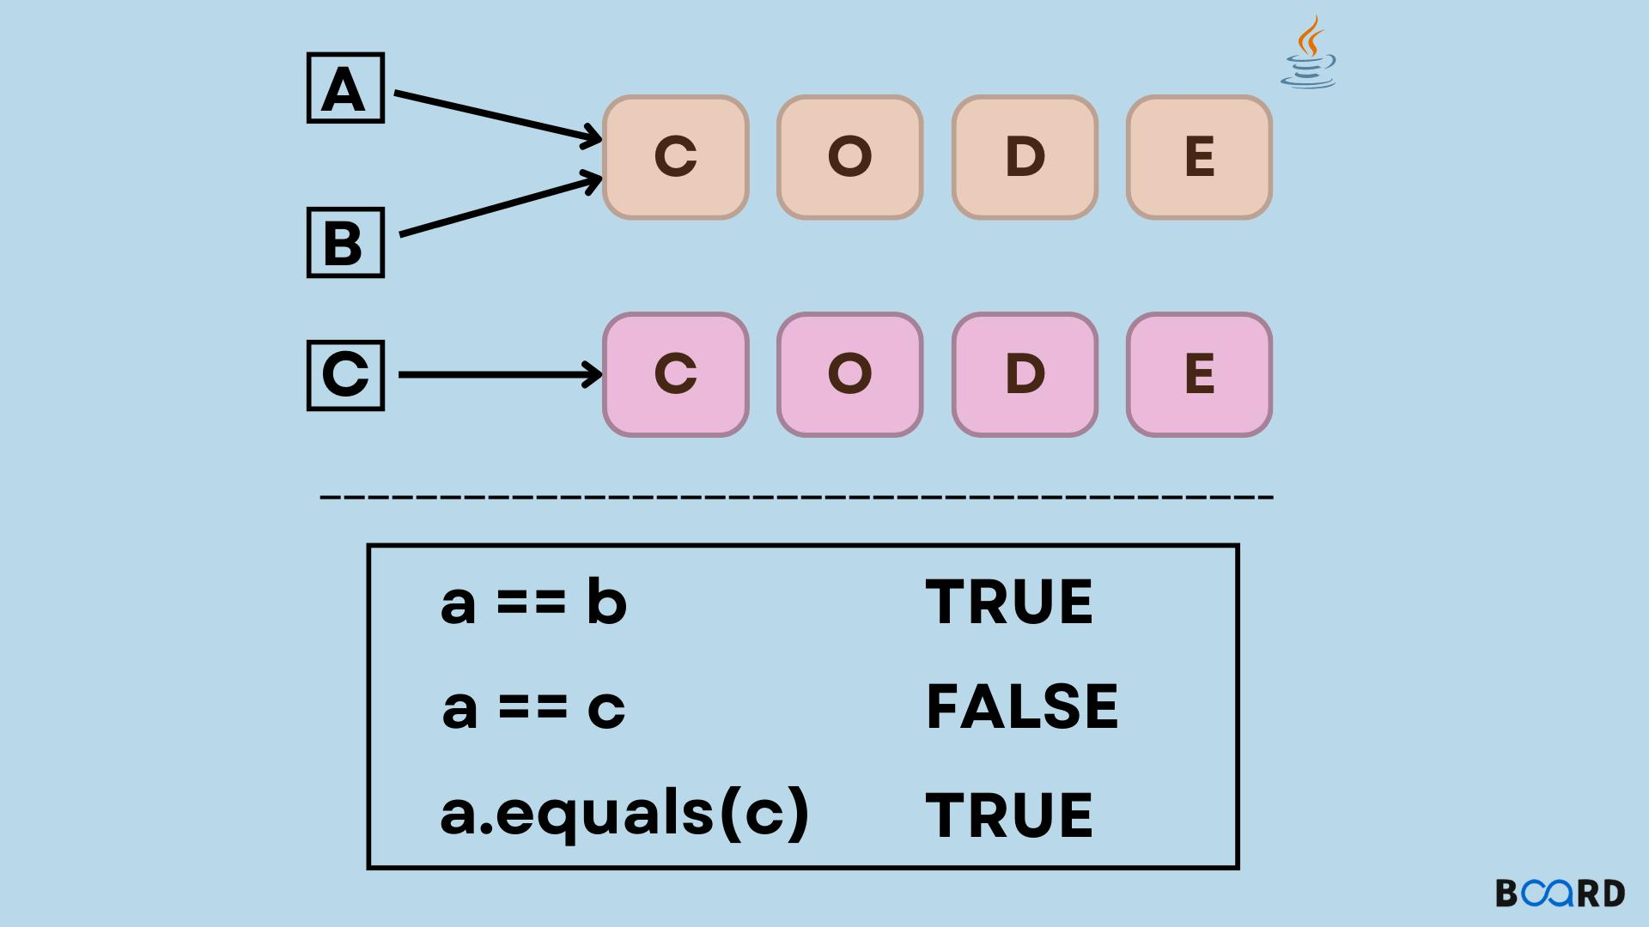
Now with new
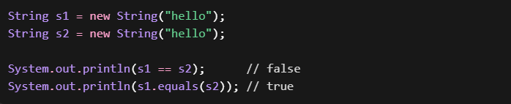
- == → different objects → ❌ false
- equals() → same content → ✅ true
Memory Representation (String Case)
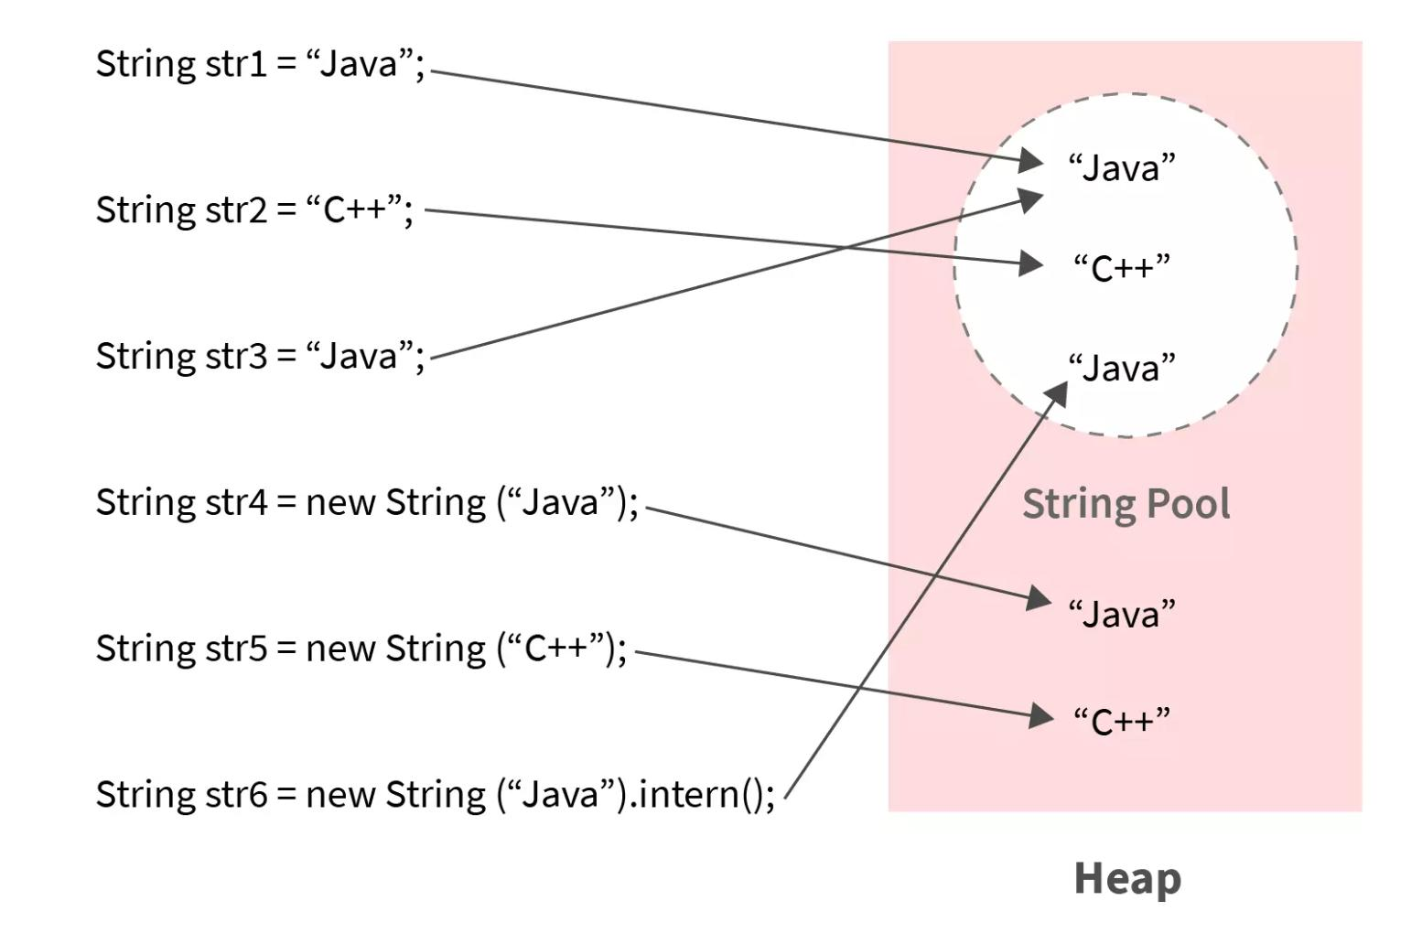
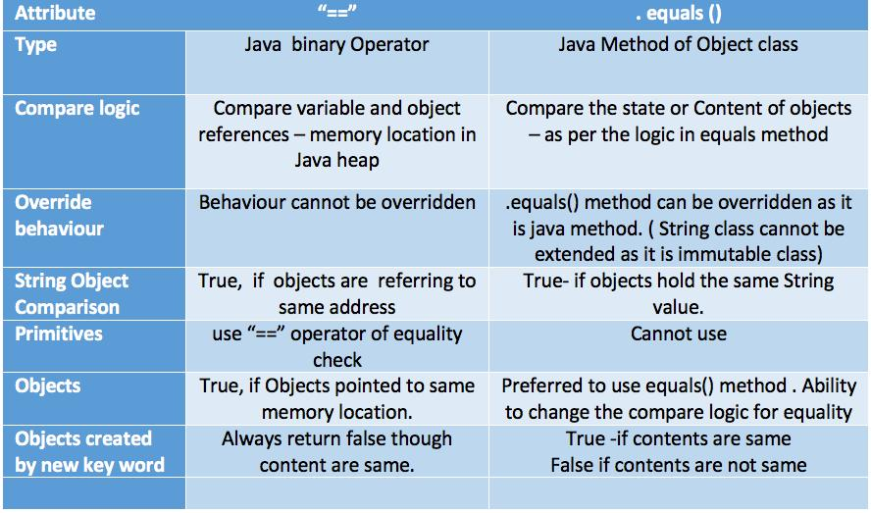

- String pool reuse
- Heap object creation with new

🔷 Example 4: Wrapper Classes (Interview Trick)
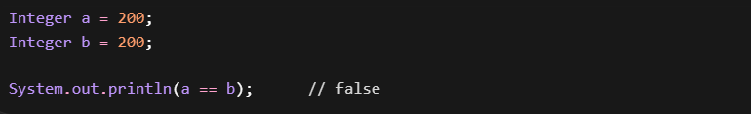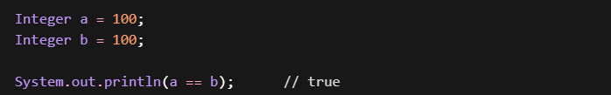
Why?
Integer caching:
- Range: -128 to 127
✔ Within range → same reference
❌ Outside range → new objects

When to Use What?
✅ Use ==
- Comparing primitives
int a = 10, b = 10;
System.out.println(a == b); // true
- Checking same object reference

✅ Use equals()
- Comparing object values
user1.equals(user2)

Understanding hashCode()
What is hashCode()
hashCode() returns an integer hash value that represents an object.
It is primarily used by hash-based collections to:
- Store objects efficiently
- Retrieve them quickly

Why Do We Need hashCode?
Imagine searching in a list of 10,000 objects:
- Without hash → check one by one → ❌ slow
- With hash → jump to bucket → ✅ fast
hashCode() is about performance optimization

How hashCode Works (Intuition)
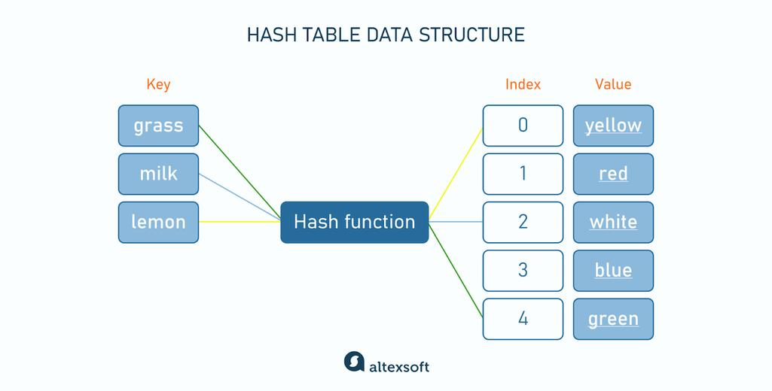
Flow:
- Object → hashCode() → integer
- Integer → bucket index
- Object stored in that bucket

Case 1: Two String objects with new
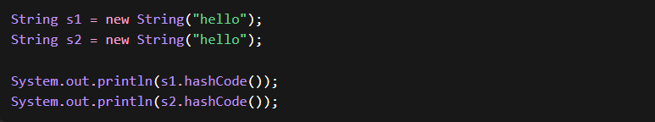Output: Same hashCode
Why?
Because in Java, String overrides hashCode()
Inside String class:
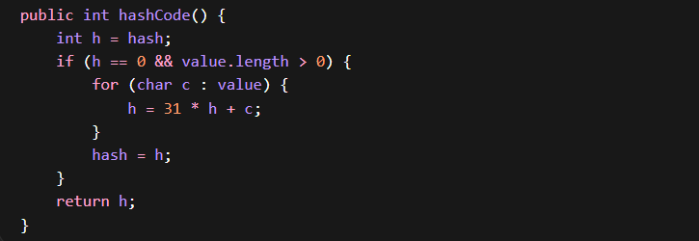
- Hash is calculated based on content ("hello")
- NOT based on memory location
- Content same → hashCode same

Case 2: Two Employee objects
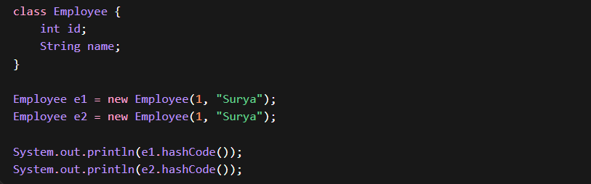
Output: Different hashCodes
Why?
Because default hashCode() comes from Object class
Default Behavior:
- Based on memory address (identity)
- NOT based on object data
So:
- e1 → different memory
- e2 → different memory
➡️ Different hashCodes
Feature | String | Employee (default)
hashCode() overridden? | ✅ | ❌
Based on content? | ✅ | ❌
Based on memory? | ❌ | ✅

Contract:
👉 If two objects are equal → hashCode MUST be same
But:
👉 Same hashCode ❌ doesn’t guarantee equality

Why your Employee fails?
Because you didn’t override:
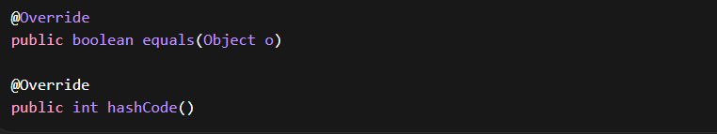
Fix: Proper Employee Class
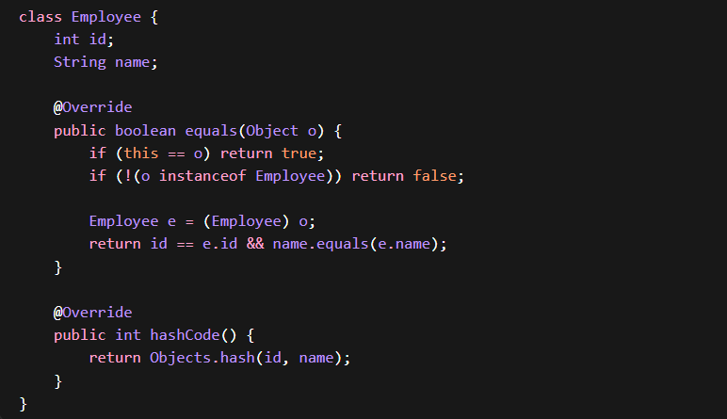
Now Behavior
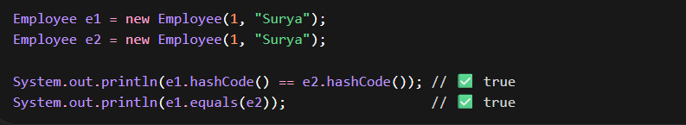

Interview Insight (Very Important)
Question:
“Why same data objects have different hashCode?”
Answer:
Because default hashCode() uses object identity (memory address). To make it data-based, we must override hashCode() and equals().

Real Use Case 1: HashMap Internal Working
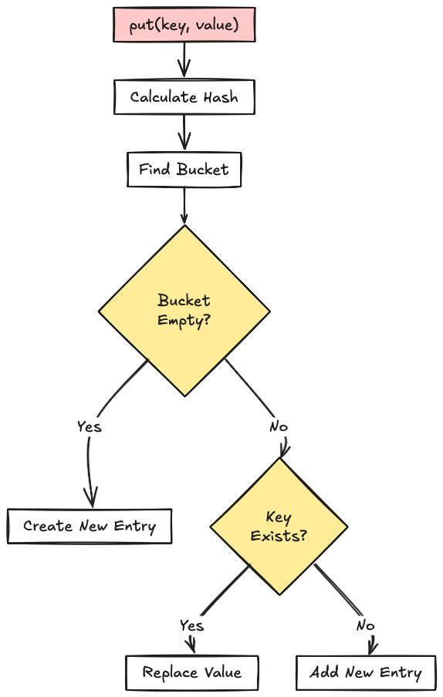
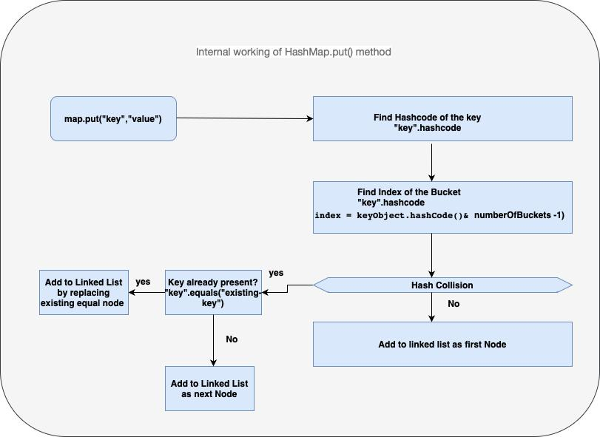

Without Proper Implementation Without Overriding equals() & hashCode()
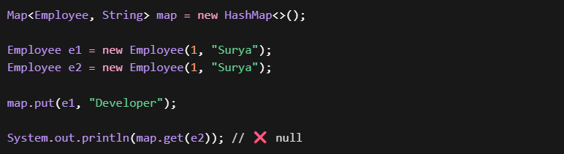
Why It Fails?
- hashCode different → different bucket
- equals not used

Correct Implementation Override hashCode() and equals()
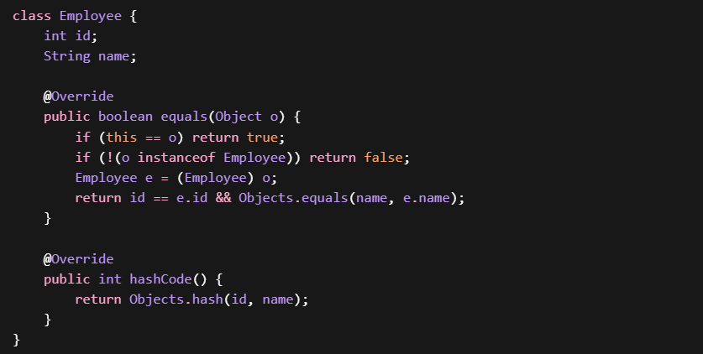
Now:
System.out.println(map.get(e2)); // Developer

How HashMap Uses equals() & hashCode()
PUT Operation (map.put(key, value))
map.put(key, value);
Step-by-step:
- Compute hashCode of key
- int hash = key.hashCode();
- Apply hash function (bit manipulation)
  - hash = hash ^ (hash >>> 16);
- Calculate bucket index
  - index = (n - 1) & hash; // n = array size
- Check bucket
  - If bucket is empty → ✅ directly insert
- If bucket NOT empty (collision case)
Traverse existing nodes:
👉 For each node:
if (node.hash == hash && node.key.equals(key))
  - ✅ If match found → replace value
  - ❌ If not → continue traversal
- If no match found
  - Add new node to bucket (linked list / tree)
- Treeify (advanced optimization)
  - If bucket size > threshold (≈8) → convert to Red-Black Tree
👉 hashCode() → decides bucket
👉 equals() → decides duplicate or new key

GET Operation (map.get(key))
map.get(key);
Step-by-step:
- Compute hashCode of key
- int hash = key.hashCode();
- Apply hash function
- hash = hash ^ (hash >>> 16);
- Find bucket index
- index = (n - 1) & hash;
- Go to bucket
  - If empty → return null
- Traverse bucket (list/tree)
For each node:
if (node.hash == hash && node.key.equals(key))
  - ✅ If match → return value
  - ❌ Else → continue
- If no match
→ return null
Example
1. Employee Class (Correct Implementation)
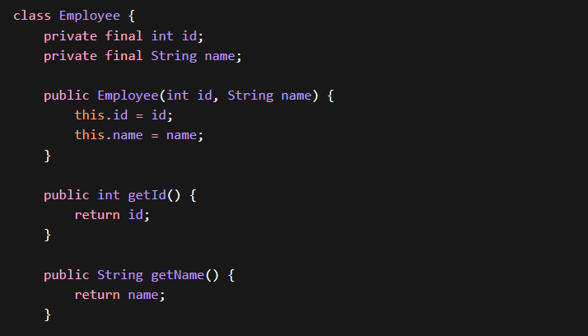
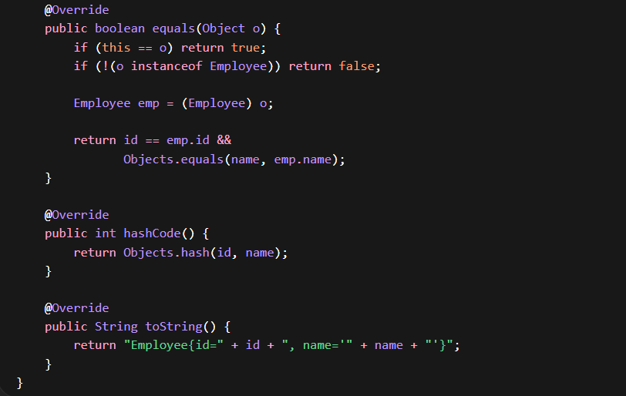

2. Basic HashMap put() and get()
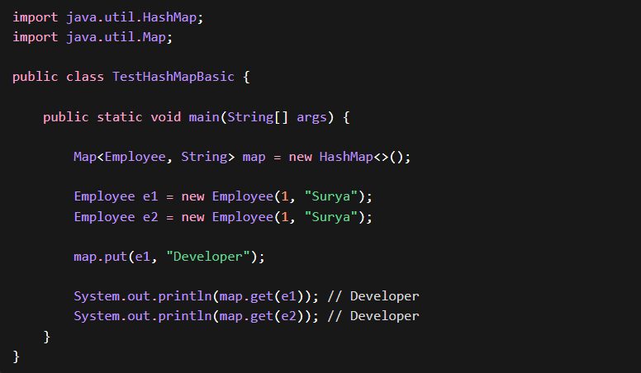
Explanation:
- e1 and e2 have same data
- Same hashCode
- equals() returns true
- Retrieval works correctly

3. Without equals() and hashCode()
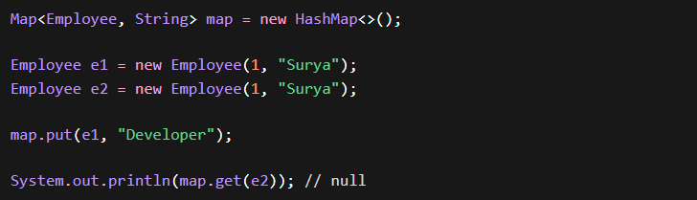
Explanation:
- Different hashCodes (memory-based)
- Different buckets
- equals() not triggered
- Retrieval fails

4. Same hashCode, equals() (Replacement Case) Correct Implementation
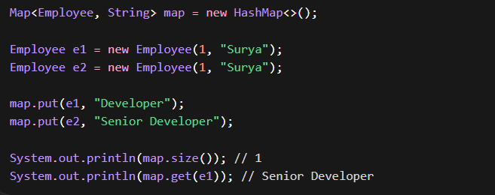
Explanation:
- Same hashCode → same bucket
- equals() → true
- Value replaced

5. Same hashCode, equals() false (Collision Case)
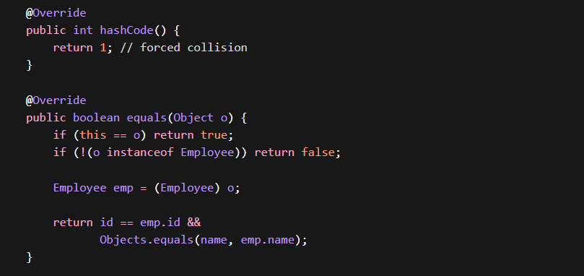
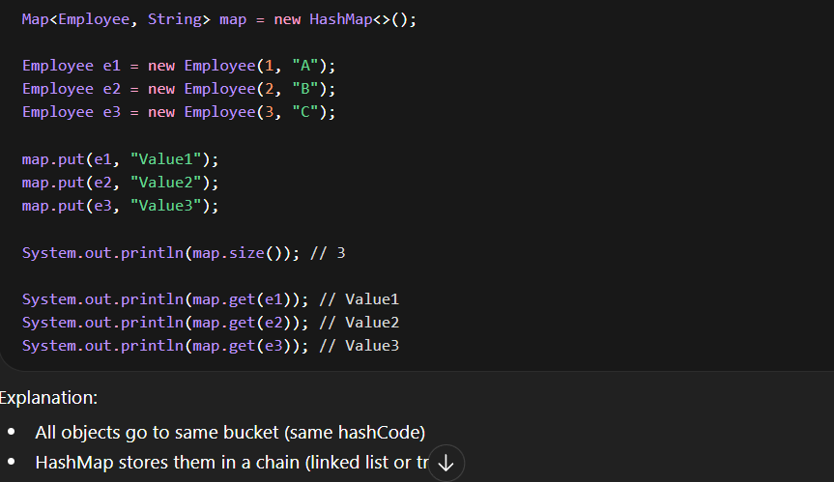
Explanation:
- All objects go to same bucket (same hashCode)
- HashMap stores them in a chain (linked list or tree)
- equals() is used to distinguish keys
- All values still retrievable
6. Same hashCode, equals() false Retrieval Flow
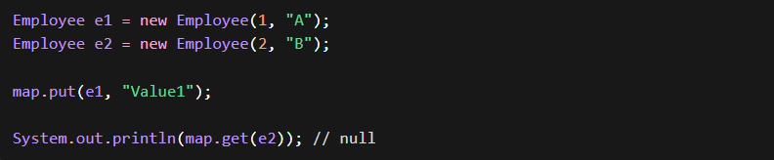
Explanation:
- Same bucket
- equals() check fails
- No match found
hashCode() is used to locate the bucket, and equals() is used to identify the exact key within that bucket.

7. Mixed Scenario (Realistic)
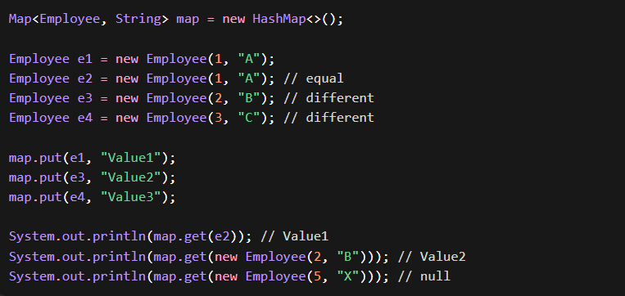
8. Internal Behavior Summary (put and get)
PUT:
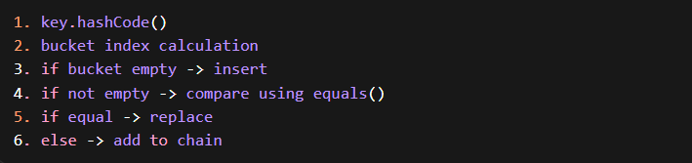
GET:
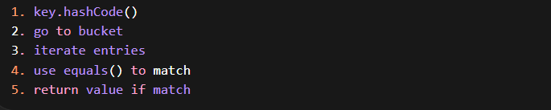
9. Important Edge Case (Mutable Key Problem)
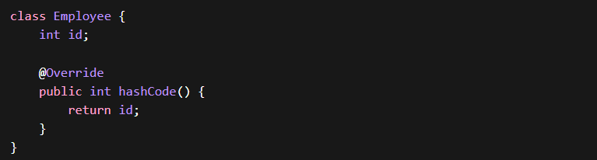
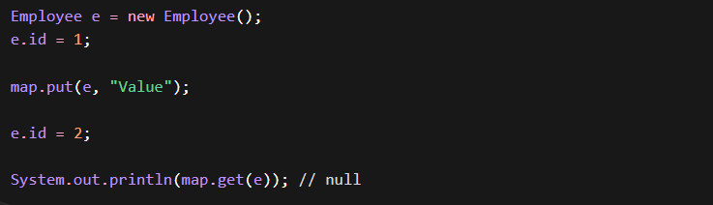
Explanation:
- hashCode changed after insertion
- object moved logically but not physically
- retrieval fails
10. Final Correct Pattern
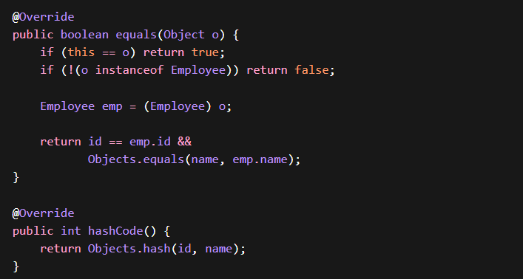
• hashCode decides bucket
• equals decides match inside bucket
• same hashCode does not mean equal
• equals true must mean same hashCode
• collisions are normal and handled internally

HashSet Internal Working

HashSet is backed by a HashMap internally
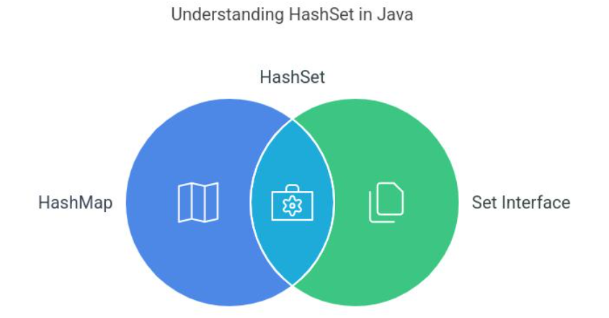
- It stores:
  - Key → your object
  - Value → constant dummy object
Internal Structure
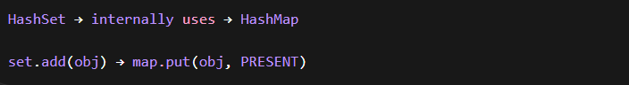

How HashSet Works (Step-by-Step)
ADD Operation
Steps:
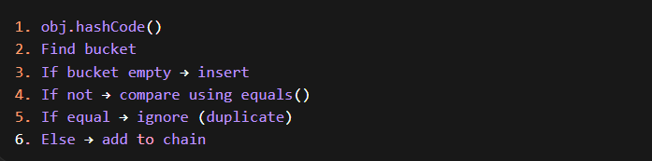
Example (Correct Implementation)
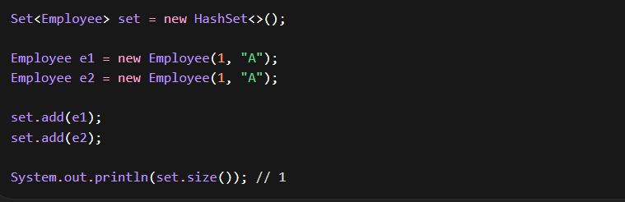
🔹 Without equals() & hashCode()
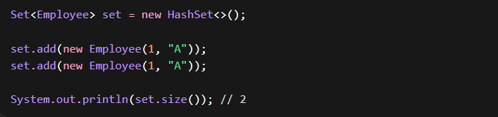
🔹 Collision Case
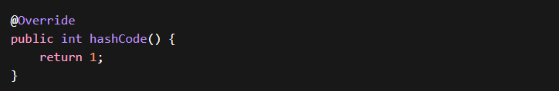
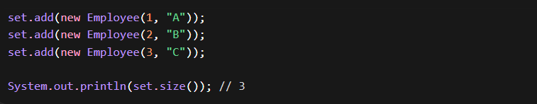
Explanation:
- Same hashCode → same bucket
- equals() → distinguishes objects

🔹 contains()
Steps:
1. hashCode()
2. go to bucket
3. equals() match

🔹 Important Insight
- HashSet uses:
  - hashCode() → bucket
  - equals() → uniqueness

TreeSet Internal Working
- TreeSet uses:
  - Red-Black Tree (self-balancing BST)
- Maintains sorted order
- Does NOT use hashCode
🔹 Uses
- Comparable OR
- Comparator

🔷 How TreeSet Works

🔹 ADD Operation
Steps:
1. compareTo() OR Comparator
2. Traverse tree
3. Insert at correct position
4. Balance tree

Example
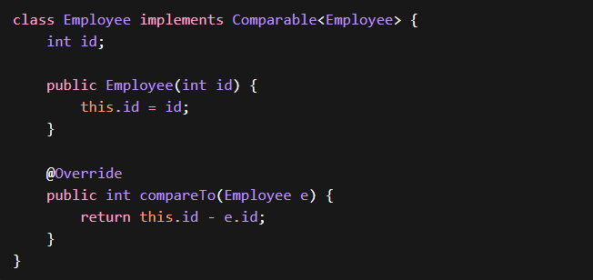
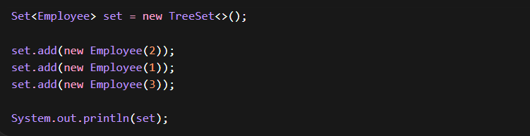
Output:
1, 2, 3

🔹 Duplicate Behavior
If compareTo() returns 0 → duplicate
Important Insight
- TreeSet uses:
  - compareTo() → ordering + equality
- equals() is NOT used for uniqueness

🔹 Tricky Case
compareTo() returns 0
equals() returns false
TreeSet still treats as duplicate

TreeMap Internal Working
TreeMap is:
  - Sorted map
  - Based on Red-Black Tree
How It Works
Steps:
1. compareTo() OR Comparator
2. Traverse tree
3. Insert node
4. Balance tree
Example
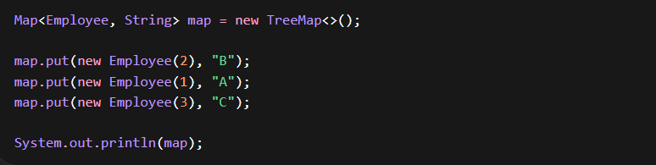Sorted by id

🔹 Duplicate Keys
👉 compareTo() == 0 → replaces value
- TreeMap uses:
  - compareTo() → ordering + key uniqueness
- equals() and hashCode() not used

HashMap Internal Structure
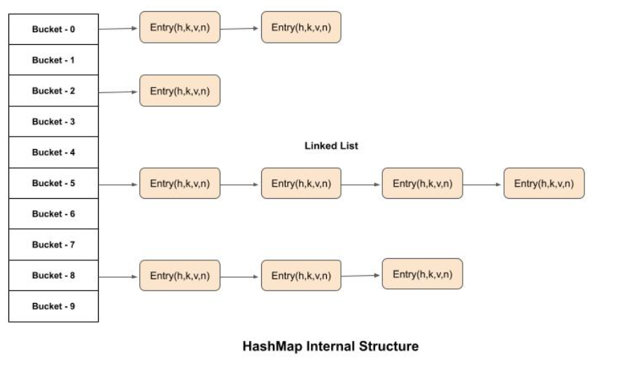
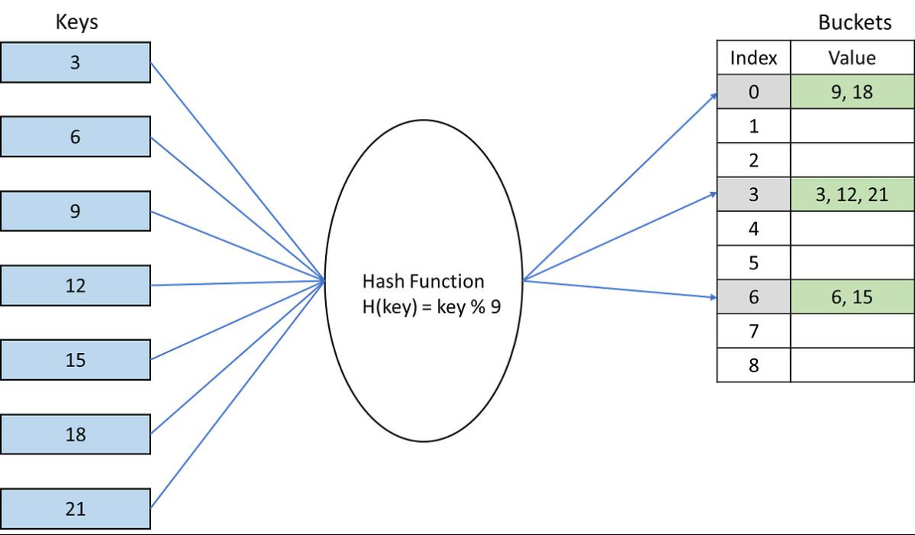

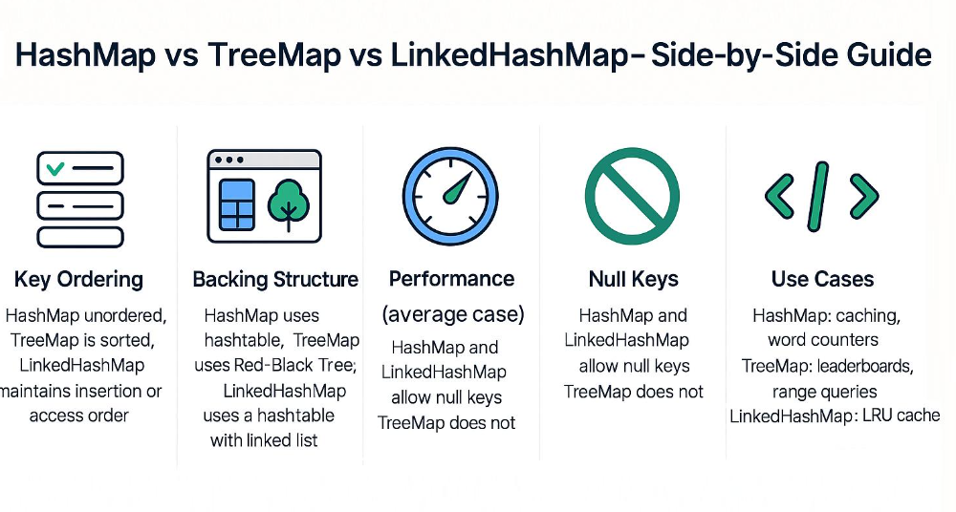
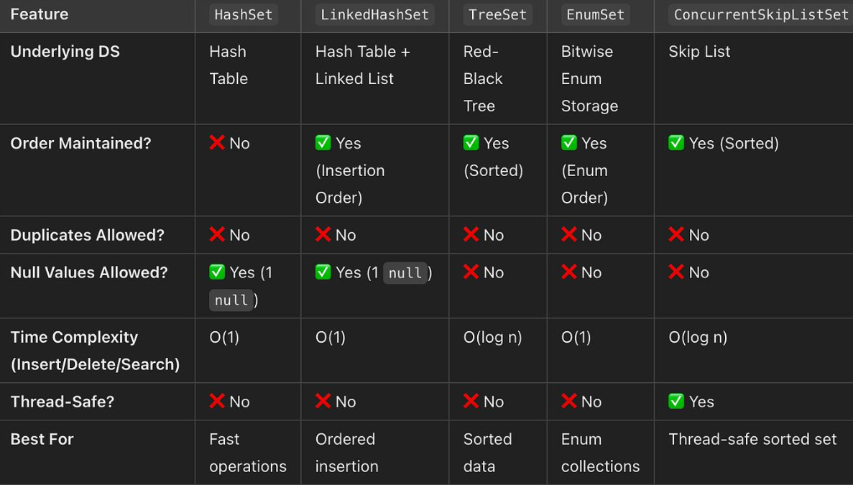

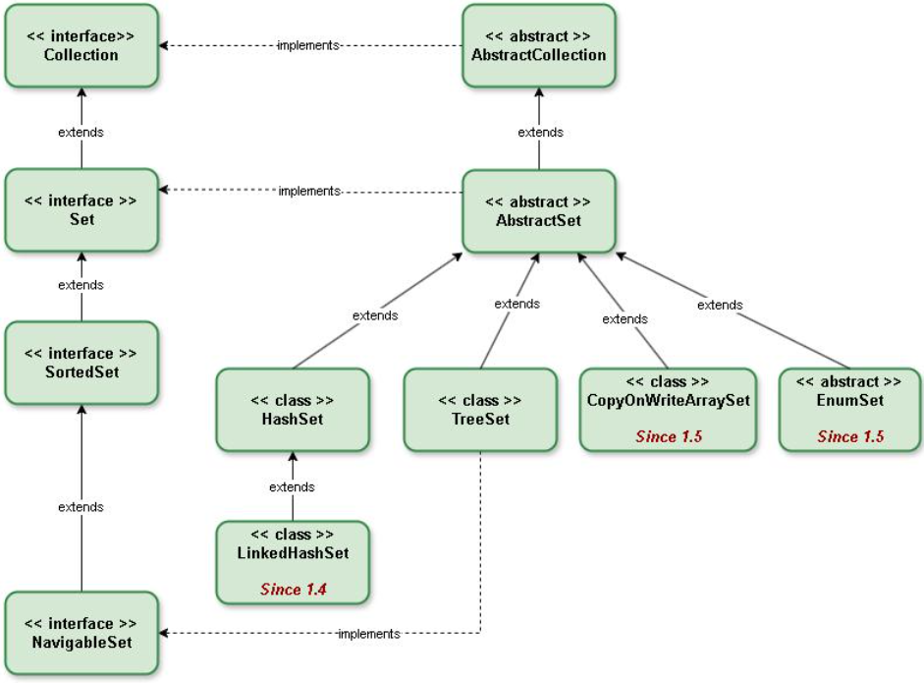

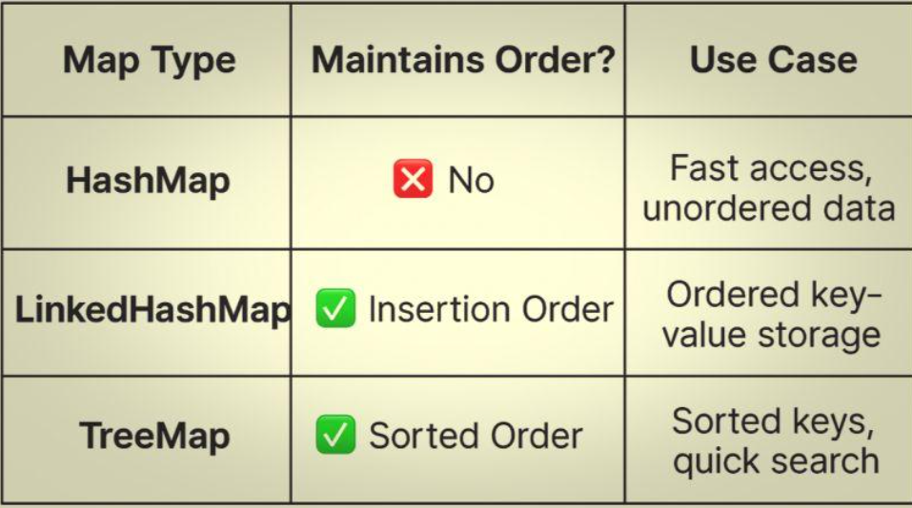

Interview Questions & Answers

1) What is the difference between == and equals()?
== compares reference (memory address), whereas equals() compares logical/content equality.
By default, equals() behaves like == (from Object), but we override it in custom classes to compare fields.

2) Why do we override equals()?
To define logical equality based on business fields (e.g., id, email).
Without overriding, collections like List.contains() or Set will not behave correctly for custom objects.

3) What is hashCode() and why is it needed?
hashCode() returns an integer used by hash-based collections to place objects into buckets for fast access.
It improves performance by reducing the search space before applying equals().

4) Explain the contract between equals() and hashCode().
If two objects are equal using equals(), they must have the same hashCode().
However, two objects with the same hashCode() are not necessarily equal (collision).
Violating this contract breaks HashMap/HashSet behavior.

5) How does HashMap use equals() and hashCode()?
- hashCode() → determines the bucket
- equals() → finds the exact key within the bucket
Both are required for correct retrieval and updates.

6) What happens if you override only equals() and not hashCode()?
Objects that are logically equal may go to different buckets, causing:
- HashMap.get() to fail
- HashSet to allow duplicates
This breaks collection correctness.

7) What happens if you override only hashCode()?
Objects may land in the same bucket, but since equals() is not aligned, duplicates or incorrect matches can occur.
Both methods must be overridden together.

8) Can two objects have the same hashCode()?
Yes. This is called a hash collision.
Java handles it by storing multiple entries in the same bucket and using equals() to distinguish them.

9) What collections use hashCode()?
- HashMap
- HashSet
- Hashtable

10) What collections do NOT use hashCode()?
- TreeSet
- TreeMap
They use comparison (compareTo() / Comparator) for ordering and equality.

11) How does HashSet ensure uniqueness?
- Uses hashCode() to find bucket
- Uses equals() to check duplicates within the bucket
If both indicate equality, the element is not added.
12) How does TreeSet determine duplicates?
Using compareTo() or Comparator.
If comparison returns 0, the element is treated as duplicate, even if equals() is false.

13) What is the difference between HashSet and TreeSet?
- HashSet → uses hashing, no order, O(1) average
- TreeSet → sorted, uses tree, O(log n)
- Equality:
  - HashSet → equals() + hashCode()
  - TreeSet → compareTo()

14) What is the difference between HashMap and TreeMap?
- HashMap → unordered, fast (O(1))
- TreeMap → sorted keys, slower (O(log n))
- Equality logic differs (hash vs compare)

15) What happens if compareTo() and equals() are inconsistent?
In TreeSet/TreeMap, equality is based on compareTo().
If compareTo() returns 0 but equals() is false, the collection will still treat objects as duplicates, leading to unexpected behavior.

16) Why should fields used in hashCode() be immutable?
If fields change after insertion into a hash-based collection, the hashCode() changes and the object becomes unreachable (cannot be found or removed).

17) Does ArrayList use hashCode()?
No. It uses only equals() for operations like contains() and remove().

18) When should you use HashMap vs TreeMap?
- Use HashMap for fast access, no ordering needed
- Use TreeMap when sorted keys or range queries are required

19) When should you use HashSet vs TreeSet?
- HashSet → when uniqueness + performance is needed
- TreeSet → when sorted unique elements are required

20) One-line summary of equality in collections?
- Hash-based: hashCode() decides where, equals() decides which
- Tree-based: compareTo() decides both where and which

“In Java collections, correct implementation of equals() and hashCode() ensures reliable behavior in hash-based structures, while compareTo() governs ordering and equality in tree-based structures. Understanding when each is used is key to writing correct and scalable backend code.”

